**SMART DIALYSIS MONITORING SYSTEM WITH AUTOMATIC CUT-OFF FACILITY**

**A PROJECT REPORT**

***Submitted by***

**MOHAMMED ASHIQ PP (724018121010)**

**MOHAMMED FASIL KV (724018121011)**

**MOHAMED ASIF (724018121027)**

**NAEEM ABDUL SALAM (724018121020)**

***In partial fulfillment for the award of the degree***

***Of***

**BACHELOR OF ENGINEERING**

***In***

**BIOMEDICAL ENGINEERING**

**DHAANISH AHMED INSTITUTE OF TECHNOLOGY, COIMBATORE**

**ANNA UNIVERSITY:: CHENNAI 600 025**

JUNE 2022



**ANNA UNIVERSITY: CHENNAI 600 025**

**BONAFIDE CERTIFICATE**

Certified that this project report “SMART DIALYSIS MONITORING SYSTEM WITH AUTOMATIC CUT-OFF FACILITY” is the bonafide work of “MOHAMMED ASHIQ PP (724018121010), MOHAMMED FASIL KV (724018121011), MOHAMED ASIF (724018121027) and NAEEM ABDUL SALAM (724018121020)” carried out the project work under my supervision.

|  |  |
| --- | --- |
|  |  |
| **SIGNATURE**  **Dr. A. KINGSLY JABAKUMAR,**  **M.E., Ph.D. ,**  **HEAD OF THE DEPARTMENT**  Associate Professor  Department of Biomedical Engineering Dhaanish Ahmed Institute of Technology,  Coimbatore - 641 105 | **SIGNATURE**  **Mrs. K. RAJARAJESWARI,**  **M.E,**  **SUPERVISOR**  Assistant Professor  Department of Biomedical Engineering  Dhaanish Ahmed Institute of Technology,  Coimbatore - 641 105 |

Submitted for the project Viva–voce Examination held on …................................. at Dhaanish Ahmed Institute of Technology, Coimbatore.

INTERNAL EXAMINER EXTERNAL EXAMINER

## ACKNOWLEDGEMENT

We authors of this project first of all thank to the almighty and our parents for providing us the right proportion of strength and knowledge for the successful completion of the project.

We would like to record our sincere thanks indebtedness and gratitude to our renowned chairman **Mr.Alhaj K.Moosa**, Director **Mr.K.A.Akbar Basha** and Chief Executive Officer **Mr.A.Thameez Ahmed B.E**., **M.B.A** for their noteworthy effort to enhance our professional dexterity and co-curricular excellence.

We gratefully acknowledge our eminent and encouraging Principal **Dr.K.G.Parthiban.M.E.Ph.D.**, Dhaanish Ahmed Institute of Technology, Coimbatore, for providing all facilities for carrying out this project very effectively and efficiently.

We express our sincere thanks to our Head of the Department **Dr.A.Kingsly Jabakumar.M.E.Ph.D,** Department of biomedical engineering,Dhaanish Ahmed institute of Technology, Coimbatore, for his constant to complete the project work

We take this opportunity to express our sincere thanks to our guide **Mrs.K.RAJARAJESWARI, Assistant Professor** Department of Biomedical engineering , Dhaanish Ahmed institute of Technology, Coimbatore, for his endless support and encouragement during this project.

We extend our sincere thanks to all our teaching and non-teaching staff members for helping us.

## ABSTRACT

The main motto of this project is to remotely monitor the dialysis process of the patient who is in need of this process. Due to the pandemic conditions like Covid-19, there exists a main drawback of tracking of patients as it involves one to one contact between patient and doctors. Moreover when the doctor needs to be closely watch the patient dialysis process, it forms nightmare to do so and hence we proposed this project in order to remotely monitor the patient dialysis process through IOT application. Through this application, the patient blood temperature, the volume of blood flows through the inlet chamber of dialysis, blood outflow from the dialysis chamber and finally the weight is monitored. Also the corresponding parameters are monitored locally though LCD display (16x2) for the physical monitoring of the dialysis process.

**TABLE OF CONTENTS**

**CHAPTER NO. TITLE PAGE NO.**

**ACKNOWLEDGEMENT ii**

**ABSTRACT iii**

**LIST OF FIGURES vii**

**LIST OF ABBREVIATIONS viii**

1. **INTRODUCTION 1** 
   1. Embedded System 1
      1. Characteristics 3
   2. Microcontroller For Embedded System 3
   3. Introduction To Smart Dialysis Monitoring 4

System

* 1. Introduction To Internet Of Things 4
  2. Introduction To Proteus Design Suite 5
     1. Product Module 5
     2. Schematic Capture 6
     3. Microcontroller Simulation 6
     4. PCB Design 6
     5. 3d Verification 7
  3. Introduction To Arduino IDE 7
  4. Objective 8

1. **LITERATURE REVIEW 9** 
   1. A New IoT Patient Monitoring System For

Hemodialysis Treatment 9

1. **EXISTING SYSTEM 11** 
   1. Problem Statement 11
2. **PROPOSED SYSTEM 12** 
   1. Block Diagram12
   2. Power Supply 13
      1. Transformer13
         1. Product Description14
         2. Features15
         3. Application15
      2. Bridge Rectifier15
      3. Voltage Regulator17
   3. Microcontroller Unit18
      1. Product Description19
      2. Features19
      3. Applications20
   4. Liquid Crystal Display20
      1. Product Description20
      2. Features21
      3. Applications21
   5. Simcom GSM Modem21
      1. Product Description22
      2. Features22
      3. Applications23
   6. Temperature Sensor (LM35)23
      1. Product Description 23
      2. Features 24
      3. Application 24
   7. I-R Sensor 25
      1. Product Description 25
      2. Features 25
      3. Applications 26

4.8 Flow Sensor 26

4.8.1 Product Description 26

4.8.2 Features 27

4.8.3 Applications 27

1. **SOFTWARE DESCRIPTION 28** 
   1. Embedded C28
   2. Arduino IDE28
2. **RESULTS AND DISCUSSION 29**
   1. Hardware Implementation 30
   2. Instruction and Data on LCD 31
   3. SMS Notification Alert 32
   4. Live Data Logging to Webpage 33
3. **CONCLUSION 34**
4. **ANNEXURE 35**

International Conference Certificate and

Journal Paper

**9 REFERENCE 41**

## LIST OF FIGURES

**FIGURE NO. FIGURE DESCRIPTION PAGE NO.**

|  |  |  |
| --- | --- | --- |
| 4.1 | Block Diagram | 12 |
| 4.2 | Power Supply | 14 |
| 4.3 | Transformer | 15 |
| 4.4 | Voltage Regulator | 18 |
| 4.5 | Arduino Uno | 19 |
| 4.6 | 16x2 LCD Display | 21 |
| 4.7 | GSM Modem | 22 |
| 4.8 | Temperature Sensor (LM35) | 24 |
| 4.9 | I-R Sensor | 26 |
| 5.1 | Flow Sensor | 27 |
| 5.2 | Hardware Implementation | 30 |
| 5.3 | Data Logging in16x2 LCD Display | 31 |
| 5.4 | SMS Notification Alert | 32 |
| 5.5 | Smart Dialysis Monitoring System Data logging into server | 33 |
|  |  |  |

## LIST OF ABBREVIATIONS

|  |  |
| --- | --- |
| IOT | Internet of Things |
| RTC | Real Time Clock |
| PCB | Printed Circuit Board |
| ADC | Analog to Digital Converter |
| LCD | Liquid Crystal Display |
| IDE | Integrated Development Environment |
| GSM | Global System for Mobile communication |
| SIM | Subscriber Identity Module |
| GNU | General Public License |
| CAD | Computer-Aided Design |
| EDA | Electronic Design Automation |
| GPRS | General Packet Radio Service |
| PWM | Pulse Width Modulation |
| SMS | Short Message Service |
| MSSP | Master Synchronous Serial Port |
| SPI | Serial Peripheral Interface |
| I2C | Inter Integrated Circuits |

**CHAPTER 1**

# INTRODUCTION

### 1.1 Embedded System

Embedded system is a combination of hardware and software used to achieve a single task within a given time frame, repeatedly and endlessly, with or without human interactions. Embedded system of a computer system which monitor and control the response of an external environment. Environment connected to system through sensors, actuators and other input output interfaces. Embedded system must meet timing and other constraints imposed on it by environment. An embedded system in general, incorporates hardware, operating system and peripheral devices and communication software to perform the predefined functions.

In contrast to desktops that perform a variety of tasks, an embedded system performs a single, well-defined task. The system has a processor, associated peripherals and software for a specific purpose. An embedded system is a computer system designed to perform one or a few dedicated functions often with real-time computing constraints. It is embedded as part of a complete device often including hardware and mechanical parts. By contrast, a general-purpose computer, such as a personal computer (PC), is to be flexible and to meet a wide range of end-user needs.

Embedded system control many devices in common use today. Embedded systems are controlled by one or more main processing cores that are typically either microcontrollers or digital signal processors (DSP). The key characteristic is being dedicated to handle a particular task, which may require very powerful processors. For example, air traffic control systems may be viewed as embedded, even though they involve mainframe computers and dedicated regional and national networks between airports and radar sites.

Since the embedded system is dedicated to specific tasks, design engineers can optimize it to reduce the size and cost of the product and increase the reliability and performance. Some embedded systems are mass-produced, benefiting from economies of scale. On a continuum from "general purpose" to "embedded", large application systems will have subcomponents at most points even if the system as a whole is "designed to perform one or a few dedicated functions", and is thus appropriate to call "embedded".

In general, "embedded system" is not a strictly definable term, as most systems have some element of extensibility or programmability. For example, handheld computers share some elements with embedded systems such as the operating systems and microprocessors which power them, but they allow different applications to be loaded and peripherals to be connected. Moreover, even systems which do not expose programmability as a primary feature generally need to support software updates.

WSN, makes use of miniaturization made possible by advanced IC design to couple full wireless subsystems to sophisticated sensors, enabling people and companies to measure a myriad of things in the physical world and act on this information through IT monitoring and control systems. These motes are completely self-contained, and will typically run off a battery source for many years before the batteries need to be changed or charged. An embedded system is a computer system that cannot be programmed by the user because it is preprogrammed for a specific task and embedded within the equipment which it serves. It has three main components:

1. It has hardware.
2. It has main application software. The application software may perform concurrently the series of tasks or multiple tasks.
3. It has a real time operating system (RTOS) that supervises the application software and provides to let the processor to run a process as per scheduling and do the context. RTOS defines the way of the system works.

##### 1.1.1 Characteristics

* Respond to external events.
* Timeless, Robustness/Safety.
* Processing power and memory limitations.
* Program stored in non-volatile memory.

### 1.2 Microcontroller for Embedded Systems

Microcontroller is a highly integrated chip that contains all the components comprising the controller. Typically it includes the CPU, RAM some form of ROM, I/O ports and timers. A printer is an example for an embedded system since a processor inside the printer does any number of applications as word processor, print Server, network server or internet terminal software for variety of applications can be loaded.

A PC can run a myriad task is that it has RAM memory and an operating system that loads the application software that is typically burned into ROM. Each embedded system has a microcontroller inside it that performs one task. One of the most critical needs of the microcontroller is to decrease the power consumption in space. This can be achieved by integrating more functions into the CPU chip.

In high performance embedded processor, the trend is to integrate more and more function into the CPU chip and let the designer to decide which feature is wanted to be used. A microcontroller is a computer-on-a-chip, or a single-chip computer. Micro suggests that the device is small, and controller tells you that the device might be used to control objects, processes, or events.

Another term to describe a microcontroller is embedded controller, because the microcontroller and its support circuits are often built into, or embedded in, the devices they control. Any device that measures, stores, controls, calculates, or displays information is a candidate for putting a microcontroller inside.

### 1.3 Introduction to Smart Dialysis Monitoring System

As we all know Haemodialysis, or simply dialysis is the process of the blood of a person whose kidneys are not working normally. The smart Internet concept (IoT) which consists of connecting everything surrounding us to Internet and making it responsible of arranging and exchanging data. In healthcare, IoT represents a developed technology integrating all the smart resources, systems, and devices ease diagnosis of diseases, to find out cures, drugs and ensure a successful follow up in one unique system.

The main objective of IoT-based smart monitoring and controlling systems is to ensure a continuous control of all the crucial patient parameters such as the body temperature, the blood pressure, the volume of blood flow during dialysis by use of a single system.

### 1.4 Introduction to Internet of Things

The Internet of things (IoT) describes the network of physical object “things” that are embedded with sensors, software, and other technologies for the purpose of connecting and exchanging data with other devices and systems over the Internet.

The definition of the Internet of things has evolved due to the convergence of multiple technologies, real-time analytics, machine learning, commodity sensors, and embedded systems. Traditional fields of embedded systems, wireless sensor networks, control systems, automation (including home and building automation), and others all contribute to enabling the Internet of things. In the consumer market, IoT technology is most synonymous with products pertaining to the concept of the "smart home", including devices and appliances like lighting fixtures, thermostats, home security systems and cameras, and other home appliances. That support one or more common ecosystems, and can be controlled via devices associated with that ecosystem as smartphones and smart speakers.

IoT implementations use different technical communications models, each with its own characteristics. Four common communications models described by the Internet Architecture Board include: Device-to-Device, Device-to-Cloud, Device-to-Gateway*,* andBack-End Data-Sharing. These models highlight the flexibility in the ways that IoT devices can connect and provide value to the user.

There are a number of serious concerns about dangers in the growth of IoT, especially in the areas of privacy and security, and consequently industry and governmental moves to address these concerns have begun including the development of international standards.

### 1.5 Introduction to Proteus Design Suite

The Proteus Design Suite is a proprietary software tool suite used primarily for electronic design automation. The software is used mainly by electronic design engineers and technicians to create schematics and electronic prints for manufacturing printed circuit boards.

It was developed in Yorkshire, England by Labcenter Electronics Ltd and is available in English, French, Spanish and Chinese languages.

##### 1.5.1 Product Module

The Proteus Design Suite is a Windows application for schematic capture, simulation, and PCB (Printed Circuit Board) layout design. It can be purchased in many configurations, depending on the size of designs being produced and the requirements for microcontroller simulation. All PCB Design products include an auto router and basic mixed mode SPICE simulation capabilities.

1.5.2 Schematic Capture

Schematic capture in the Proteus Design Suite is used for both the simulation of designs and as the design phase of a PCB layout project. It is therefore a core component and is included with all product configurations

##### 1.5.3 Microcontroller Simulation

The micro-controller simulation in Proteus works by applying either a hex file or a debug file to the microcontroller part on the schematic. It is then co simulated along with any analog and digital electronics connected to it. This enables its use in a broad spectrum of project prototyping in areas such as motor control, temperature control and user interface design. It also finds use in the general hobbyist community and, since no hardware is required, is convenient to use as a training or teaching tool. Support is available for co-simulation of:

* Microchip Technologies PIC10, PIC12, PIC16, PIC18, PIC24, dsPIC33 Microcontrollers.
* Atmel AVR (and Arduino), 8051 and ARM Cortex-M3 Microcontrollers
* NXP 8051, ARM7, ARM Cortex-M0 and ARM Cortex-M3

Microcontrollers.

* Texas Instruments MSP430, PICCOLO DSP and ARM Cortex-M3 Microcontrollers.
* Parallax Basic Stamp, Freescale HC11, 8086 Microcontrollers.

##### 1.5.4 PCB Design

The PCB Layout module is automatically given connectivity information in the form of a netlist from the schematic capture module. It applies this information, together with the user specified design rules and various design automation tools, to assist with error free board design. PCB's of up to 16 copper layers can be produced with design size limited by product configuration.

##### 1.5.5 3D Verification

The 3D Viewer module allows the board under development to be viewed in 3D together with a semi-transparent height plane that represents the board’s enclosure. STEP output can then be used to transfer to mechanicalCAD software such as Solidworks or Autodesk for accurate mounting and positioning of the board.

### 1.6 Introduction to Arduino IDE

The Arduino Integrated Development Environment (IDE) is a cross platform application (for Windows, mac OS, Linux) that is written in functions from C and C++. It is used to write and upload programs to Arduino compatible boards, but also, with the help of third-party cores, other vendor development boards.

The source code for the IDE is released under the General Public License (GNU), version 2. The Arduino IDE supports the languages C and C++ using special rules of code structuring. The Arduino IDE supplies a software library from the Wiring project, which provides many common input and output procedures. User-written code only requires two basic functions, for starting the sketch and the main program loop, that are compiled and linked with a program stub main() into an executable cyclic executive program with the GNU tool chain, also included with the IDE distribution. The Arduino IDE employs the program AVRDUDE to convert the executable code into a text file in hexadecimal encoding that is loaded into the Arduino board by a loader program in the board's firmware. By default, AVRDUDE is used as the uploading tool to flash the user code onto official Arduino boards.

### 1.7 Objective

The objectives of Smart Dialysis Monitoring System is to remotely monitor the dialysis process of the patient who is in need of this process. For research purposes, it is necessary to know the patients parameters. Additionally, when these parameters goes beyond the pre-determined value, automatically the dialysis procedure is paused and the alert notification will be sent to the nurse station through SMS.

* We can reduce the patients contact with nurse\ doctor.
* Improves the patient experience.
* Reduce the per capital cost of health care.
* Dialysis operator (nurse) does not need to be present throughout the procedure.
* Resolve the problem of limited staff.

**CHAPTER 2**

# LITERATURE REVIEW

### 2.1 A NEW IOT PATIENT MONITORING SYSTEM FOR HEMODIALYSIS TREATMENT

Internet of Things (IoT) represents the smart Internet concept which consists of connecting everything surrounding us to Internet and making it responsible of arranging and exchanging. Numerous studies have been conducted concerning IoT technologies and all showed that there is significant and urgent need for platforms development. IoT significantly spread in healthcare through the development of new platforms giving birth to Internet of Medical Things (IoMT). It is todays at the highest peak as it has essential potentialities among all other types of IoT applications. In healthcare, IoT represents a developed technology integrating all the smart resources, systems, and devices ease diagnosis of diseases, to find out cures, drugs and ensure a successful follow up in one unique system. Recording information became fundamental since it constitute a successful health providing a complete report about a detailed daily status of patients can be provided. Modern Technology is necessary for any type of data recording to ease and quicker this process through a local network where mechanisms connect with each other to share and communicate information. The main objective of IoT-based monitoring and controlling systems is to ensure a continuous control of all the crucial patient parameters such as the body temperature, the blood pressure, the glycemic index, or even the electrocardiography and SpO2. Such systems can be crucial and very useful for all health mechanisms and treatments especially dialysis patients who require a more tiring and detailed process for data gathering, and who do not always have the strength to reach hemodialysis facilities. Some patients may be living in rural communities or in harsh living conditions and cannot easily access to dialysis institutions as they are very limited.

The study mainly focuses on hemodialysis patients that are required to be monitored their heart rate. The heart rate could be the identifier of the requirement for the dialysis. Water retention in dialysis patient could increase the heart rate that indicates the urgent treatment.

**CHAPTER 3**

# EXISTING SYSTEM

In the existing system of methodology, continuous monitoring of crucial patient parameters like temperature, blood pressure, glycemic index, SpO2.

### 3.1 Problem Statement

* Absence of the blood bubble detection system.
* Doesn’t have SMS notification and triggering alert.
* We can’t monitor from remote location.
* Automatic Cut-Off facility is available.

**CHAPTER 4**

# PROPOSED SYSTEM

### 4.1 Block Diagram

**MICROCONTROLLER**

**UNIT**

**CAPACITIVE FILTER**

**BRIDGE**

**RECTIFIER**

**AC**

**MAINS**

**STEP DOWN**

**TRANSFORMER**

**16X2 LCD DISPLAY**

**VOLTAGE REGULATOR**

**TEMPERAURE SENSOR**

**BLOOD IN FLOW SENSOR**

**BLOOD OUT FLOW SENSOR**

**NPN DRIVER**

**BUZZER**

**AIR BUBBLE DETECTOR**

**SIMCOM GSM MODEM**

**SMS AND CALL ALERT**

**EMERGENCY CUTOFF RELAY**

Fig: 4.1Block Diagram

The above figure represents the systematic block diagram of this project. As shown in the block diagram, AC mains are described in order to fetch the power from the AC main source and which is further step downed by the step down transformer in order to get the low voltage AC signal from the high voltage Ac signal. Thus obtained AC signal is processed through bridge rectifier in order to extract the DC voltage which is required to operate the microcontroller. Thus the obtained DC source is an unregulated and rippled DC power source, the capacitive filter and voltage regulator like 7805 are used to obtain regulated DC power source for the microcontroller operation.

### 4.2 Power Supply

A regulated power supply is an embedded circuit; it converts unregulated AC into a constant DC. With the help of a rectifier it converts AC supply into DC. Its function is to supply a stable voltage, to a circuit or device that must be operated within certain power supply limits. The output from the regulated power supply may be alternating or unidirectional, but is nearly always DC. The type of stabilization used may be restricted to ensuring that the output remains within certain limits under various load conditions, or it may also include compensation for variations in its own supply source. The latter is much more common today.

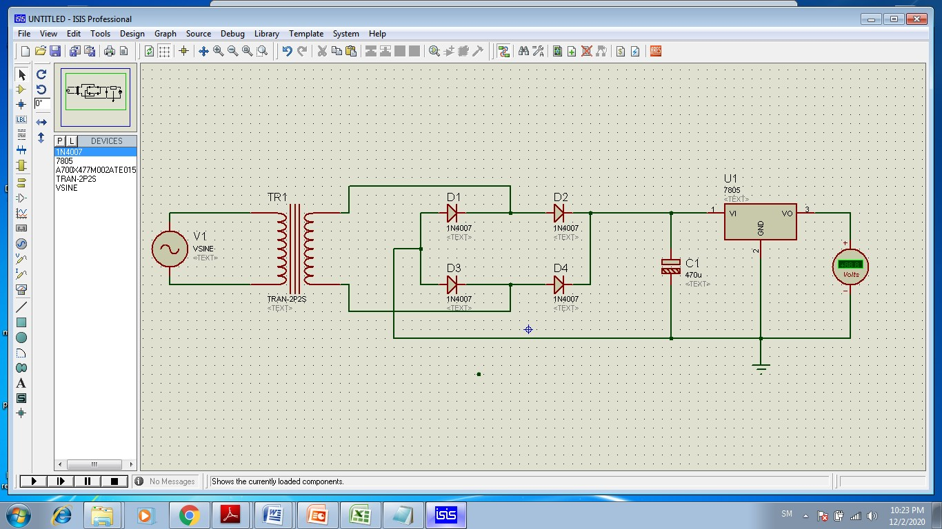

Fig: 4.2 Power supply

#### 4.2.1 Transformer

The potential transformer will step down the power supply voltage (0-230V) to (0-6V) level. Then the secondary of the potential transformer will be connected to the precision rectifier, which is constructed with the help of op–amp. The advantages of using precision rectifier are it will give peak voltage output as DC, rest of the circuits will give only RMS output.

It is a general purpose chassis mounting mains transformer. Transformer has 240V primary windings and center tapped secondary winding. The transformer has flying colored insulated connecting leads (Approx. 100 mm long). The Transformer act as step down transformer reducing AC - 240V to AC - 12V. Power supplies for all kinds of project & circuit boards.

Step down 230 V AC to 12V with a maximum of 1Amp current. In AC circuits, AC voltage, current and waveform can be transformed with the help of Transformers. Transformer plays an important role in electronic equipment. AC and DC voltage in Power supply equipment are almost achieved by transformer’s transformation and commutation

###### 4.2.1.1 Product Description

A transformer is an electrical device that transfers electrical energy between two or more circuits through electromagnetic induction. Electromagnetic induction produces an electromotive force within a conductor which is exposed to time varying magnetic fields. Transformers are used to increase or decrease the alternating voltages in electric power applications.

It is a step down transformer in which the secondary winding is more than primary winding. Due to this windings it can able to step down the voltage. A Transformer changes electricity from high to low voltage or low to high voltage using two properties of electricity.

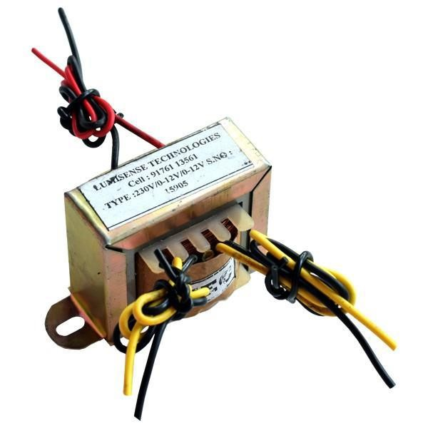

Fig: 4.3 Transformer

###### 4.2.1.2 Features

* Output current:1A
* Supply voltage: 220-230VAC
* Output voltage: 12VAC
* Soft Iron Core
* 1Amp Current Drain

###### 4.2.1.3 Application

* DIY projects Requiring In-Application High current drain.
* On chassis AC/AC converter.
* Designing a battery Charger.
* Electronic applications.
* Step down applications.

#### 4.2.2 Bridge Rectifier

When four diodes are connected as shown in figure, the circuit is called as bridge rectifier. The input to the circuit is applied to the diagonally opposite corners of the network, and the output is taken from the remaining two corners. Let us assume that the transformer is working properly and there is a positive potential, at point A and a negative potential at point B. The positive potential at point A will forward bias D3 and reverse bias D4. The negative potential at point B will forward bias D1 and reverse D2. At this time D3 and D1 are forward biased and will allow current flow to pass through them; D4 and D2 are reverse biased and will block current flow. The path for current flow is from point B through D1, up through RL, through D3, through the secondary of the transformer back to point B. this path is indicated by the solid arrow.

One-half cycle later the polarity across the secondary of the transformer reverse, forward biasing D2 and D4 and reverse biasing D1 and D3. Current flow will now be from point A through D4, up through RL, through D2, through the secondary of T1, and back to point A. This path is indicated by the broken arrows. The current flow through RL is always in the same direction. Since current flows through the load (RL) during both half cycles of the applied voltage, this bridge rectifier is a full-wave rectifier.

One advantage of a bridge rectifier over a conventional full wave rectifier is that with a given transformer the bridge rectifier produces a voltage output that is nearly twice that of the conventional full-wave circuit. This may be shown by assigning values to some of the components shown in views A and B. assume that the same transformer is used in both circuits. The peak voltage developed between points X and y is 1000 volts in both circuits. Since only one diode can conduct at any instant, the maximum voltage that can be rectified at any instant is 500 volts. The maximum voltage that appears across the load resistor is nearly-but never exceeds-500 v0lts, as result of the small voltage drop across the diode. Current flows through the load during both half cycles of the applied voltage. In the bridge rectifier shown in view B, the maximum voltage that can be rectified is the full secondary voltage. Therefore, the peak output voltage across the load resistor is nearly 1000 volts. With both circuits using the same transformer, the bridge rectifier circuit produces a higher output voltage than the conventional full-wave rectifier circuit. In the conventional full-wave circuit, the peak voltage from the center tap to either X or Y is 500 volts.

The path for current flow is from point B through D1, up through RL, through D3, through the secondary of the transformer back to point B. this path is indicated by the solid arrows. One-half cycle later the polarity across the secondary of the transformer reverse, forward biasing D2 and D4 and reverse biasing D1 and D3. Current flow will now be from point A through D4, up through RL, through D2, through the secondary of T1, and back to point A. This path is indicated by the broken arrows.

The current flow through RL is always in the same direction.

#### 4.2.3 Voltage Regulator

Regulator IC units contain the circuitry for reference source, comparator amplifier, and overload protection all in a single IC.

The regulators can be selected for operation with load currents from hundreds of milliamperes to tens of amperes, corresponding to power ratings from milliwatts to tens of watts. The series 78 regulators provide fixed positive regulated voltages from 5 to 24 volts.

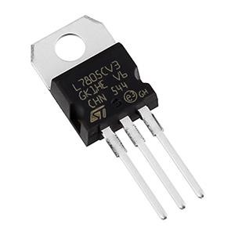

Fig: 4.4 Voltage regulator

The series 79 regulators provide fixed negative regulated voltages from 5 to 24 volts. A fixed three-terminal voltage regulator has an unregulated dc input voltage, Vi applied to one input terminal, a regulated dc output voltage, Vo, from a second terminal, with the third terminal connected to ground. The series 78 regulators provide fixed positive regulated voltages from 5 to 24 volts. Similarly, the series 79 regulators provide fixed negative regulated voltages from 5 to 24 volts. For ICs microcontroller, LCD - 5 volts. For alarm circuit, op-amp, relay circuits -12 volts.

## 4.3 Microcontroller Unit

Arduino is an open-source project that created microcontroller based kits for building digital devices and interactive objects that can sense and control physical devices. The project is based on microcontroller board designs, produced by several vendors, using various microcontrollers. These systems provide sets of digital and analog input/output pins that can interface to various expansion boards (termed shields) and other circuits. The boards feature serial communication interfaces, including Universal Serial Bus on some models, for loading programs from personal computers. For programming the microcontrollers, the Arduino project provides an integrated development environment (IDE) based on a programming language named Processing, which also supports the languages C and C++.

#### 4.3.1 Product Description

Arduino Uno is a microcontroller board based on the ATmega328P. It has 14 digital input/output pins, 6th pin can be used as PWM outputs, 6 Analog inputs, a 16 MHz quartz crystal, a USB connection, a power jack, an ICSP header and a reset button. It contains everything needed to support the microcontroller; simply connect it to a computer with a USB cable or power it with an AC-to-DC adapter. Arduino Uno has a number of facilities for communicating with a computer, another Arduino board, or other microcontrollers.

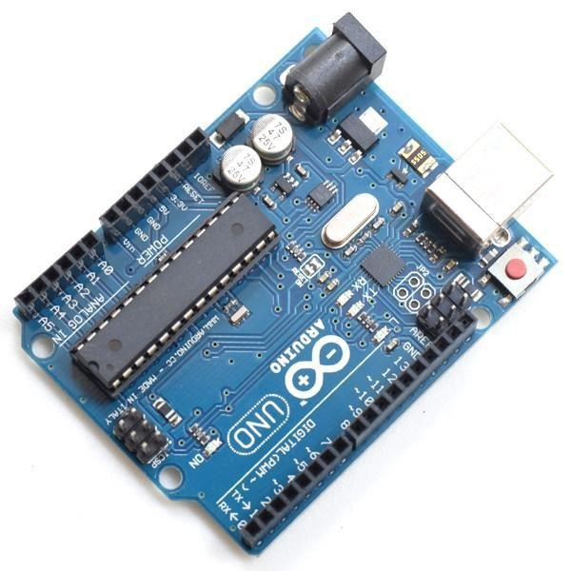

Fig: 4.5 Arduino Uno

#### 4.3.2 Features

* Microcontroller: ATmega328P
* Operating voltage: 5V
* Input voltage: 7-12V
* Flash memory: 32KB
* SRAM: 2KB
* EEPROM: 1KB

#### 4.3.3 Applications

* Real time biometrics
* Robotic applications
* Academic applications

## 4.4 Liquid Crystal Display

LCD stands for liquid crystal display. They come in many sizes 8x1 , 8x2, 10x2 , 16x1 , 16x2 , 16x4 , 20x2 , 20x4 ,24x2 , 30x2 , 32x2 , 40x2 etc. . Many multinational companies like Philips Hitachi Panasonic make their own special kind of LCD'S to be used in their products. All the LCD'S performs the same functions. Their programming is also same and they all have same 14 pins (0-13) or 16 pins (0 to 15). Alphanumeric displays are used in a wide range of applications, including palmtop computers, word processors, photocopiers, point of sale terminals, medical instruments, cellular phones, etc.

#### 4.4.1 Product Description

This is an LCD Display designed for E-blocks. It is a 16 character, 2-line alphanumeric LCD display connected to a single 9-way D-type connector. This allows the device to be connected to most E-Block I/O ports. The LCD display requires data in a serial format, which is detailed in the user guide below. The display also requires a 5V power supply. Please take care not to exceed 5V, as this will cause damage to the device. The 5V is best generated from the E-blocks Multi programmer or a 5V fixed regulated power supply.

The 16 x 2 intelligent alphanumeric dot matrix displays is capable of displaying 224 different characters and symbols. A full list of the characters and symbols is printed on pages 7/8 (note these symbols can vary between brand of LCD used). This booklet provides all the technical specifications for connecting the unit, which requires a single power supply (+5V).

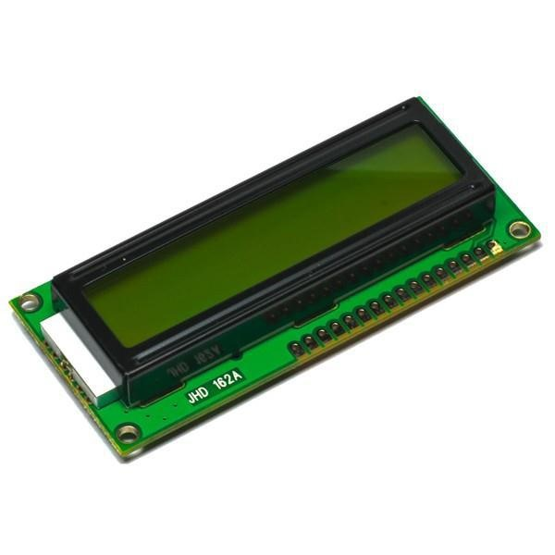

Fig: 4.6 16X2 LCD display

#### 4.4.2 Features

* Input voltage: 5v
* E-blocks compatible
* Low cost
* Compatible with most I/O ports in the E-Block range
* Ease to develop programming code using Flow code icons

#### 4.4.3 Applications

➢ Data Monitoring Purposes

## 4.5 Simcom GSM Modem

This GSM Modem can work with any GSM network operator SIM card just like a mobile phone with its own unique phone number. Advantage of using this modem will be that its RS232 port can be used to communicate and develop embedded applications. Applications like SMS Control, data transfer, remote control and logging can be developed easily using this.

The modem can either be connected to PC serial port directly or to any microcontroller through MAX232. It can be used to send/receive SMS and make/receive voice calls. It can also be used in GPRS mode to connect to internet and run many applications for data logging and control. In GPRS mode you can also connect to any remote FTP server and upload files for data logging.

#### 4.5.1 Product Description

This GSM Modem can accept any GSM network act as SIM card and just like a mobile phone with its own unique phone number. Advantage of using this modem will be that you can use its RS232 port to communicate and develop embedded applications. The SIM800C is a complete Dual-band GSM/GPRS solution in a SMT module featuring an industry-standard interface, the SIM800CS is a quad-band GSM/GPRS module that works on frequencies GSM850MHz, delivers performance for voice, SMS, Data, and Fax in a small form factor and with low power consumption.

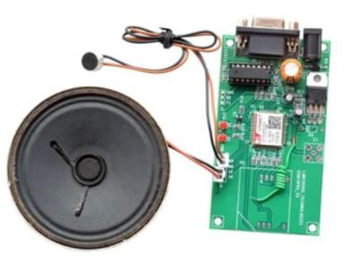

Fig: 4.7 GSM modem

#### 4.5.2 Features

* High Quality Product
* RS232 interface @ RMC Connector for direct communication with computer or MCU kit.
* Configurable baud rate.
* SMA connector with GSM Antenna.
* SIM Card holder.
* Built in Network Status LED
* Inbuilt Powerful TCP/IP protocol stack for internet data transfer over GPRS.
* Audio interface Connector
* Normal operation temperature: -20 °C to +55 °C
* Input Voltage: 4.5V-12V DC

#### 4.5.3 Applications

* short message service(SMS)
* incoming/outgoing voice calls
* SMS based Remote Control and Alerts
* Security Applications
* Sensor Monitoring
* GPRS Mode Remote Data logging

## 4.6 Temperature Sensor (LM35)

The LM35 series are precision integrated-circuit temperature sensors, whose output voltage is linearly proportional to the Celsius (Centigrade) temperature. The LM35 thus has an advantage over linear temperature sensors calibrated in ˚ Kelvin, as the user is not required to subtract a large constant voltage from its output to obtain convenient Centigrade scaling. The LM35 does not require any external calibration or trimming to provide typical accuracies of ±1⁄4˚C at room temperature and ±3⁄4˚C over a full −55 to +150˚C temperature range.

**4.6.1 Product Description**

The LM35’s low output impedance, linear output, and precise inherent calibration make interfacing to readout or control circuitry especially easy. It can be used with single power supplies, or with plus and minus supplies. The LM35 can be applied easily in the same way as other integrated-circuit temperature sensors. It can be glued or cemented to a surface and its temperature will be within about 0.01˚C of the surface temperature. This presumes that the ambient air temperature is almost the same as the surface temperature; if the air temperature were much higher or lower than the surface temperature, the actual temperature of the LM35 die would be at an intermediate temperature between the surface temperature and the air temperature. This is especially true for the TO-92 plastic package, where the copper leads are the principal thermal path to carry heat into the device, so its temperature might be closer to the air temperature than to the surface temperature.

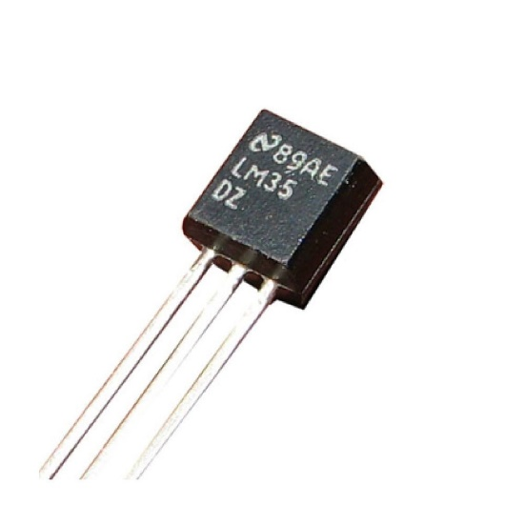

Fig: 4.8 LM35

**4.6.2 Features**

* Input voltage : 4 to 30 volts
* Rated temperature : −55˚ to +150˚C range
* Calibrated directly in ˚Celsius.
* Suitable for remote applications.

#### 4.6.3 Applications

* Measuring the temperature of a particular environment.
* Provides thermal shut down for a circuit or component.

## 4.7 I-R Sensor

IR LED emits infrared radiation. This radiation illuminates the surface in front of LED. Depending on reflectivity of the surface, amount of light reflected varies. This reflected light is made incident on reverse biased IR sensor. The amount of electron-hole pairs generated depends on intensity of incident IR radiation. Thus as intensity of incident ray varies, voltage across resistor will vary accordingly.

#### 4.7.1 Product Description

An infrared sensor is an electronic device, which emits in order to sense some aspects of the surroundings. An IR sensor can measure the heat of an object as well as detects the motion. Usually in the infrared spectrum, all the objects radiate some form of thermal radiations. These types of radiations are invisible to our eyes that can be detected by an infrared sensor.

The emitter is simply an IR LED (Light Emitting Diode) and the detector is simply an IR photodiode which is sensitive to IR light of the same wavelength as that emitted by the IR LED. When IR light falls on the photodiode, the resistances and these output voltages, change in proportion to the magnitude of the IR light received.

#### 4.7.2 Features

* Operating voltage:5VDC
* Output voltage: 0 or 5VDC
* Easy to assemble and use.
* Onboard detection indication.
* Effective distance range of 2cm.

#### 4.7.3 Applications

* Augmentative communication devices
* Computers
* Signage
* Car locking systems

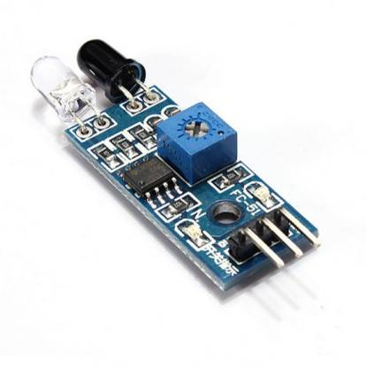

Fig: 4.9 I-R Sensor

## 4.8 Flow Sensor

Flow sensor consists of a plastic valve body, a rotor, and a hall-effect sensor. When liquid flows through the rotor, rotor rolls. Its speed changes with different rate of flow. The hall-effect sensor outputs the corresponding pulse signal. This one is suitable to detect flow of liquid in many applications. There is a comprehensive line of flow sensors in different diameters.

## 4.8.1 Product Description

YF-S201 is a flow measurement sensor with high-grade quality sealing property. It works on the Hall Effect principle and with a flow rate range of 1~30L/min. The module has three pins: Power, Ground, and the Analog output. YF-S201 consumes very little current and can work with an allowing pressure of ≤1.75MPa.

#### 4.8.2 Features

* Compact, Easy to Install
* High Sealing Performance
* High Quality Hall Effect Sensor
* RoHS Compliant

#### 4.8.3 Applications

* Water vending machine
* Flow measurement device

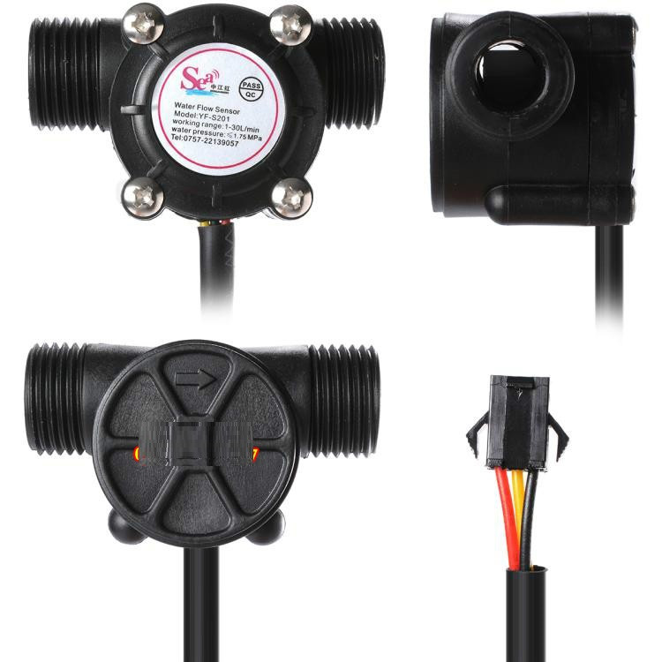

Fig: 5.1 Flow Sensor

**CHAPTER 5**

# SOFTWARE DESCRIPTION

### 5.1 Embedded C

Embedded C is a set of language extensions for the C programming language by the C Standards Committee to address commonality issues that exist between C extensions for different embedded systems.

Embedded C programming typically requires nonstandard extensions to the C language in order to support enhanced microprocessor features such as fixed-point arithmetic, multiple distinct memory banks, and basic I/O operations. In 2008, the C Standards Committee extended the C language to address such capabilities by providing a common standard for all implementations to adhere to. It includes a number of features not available in normal C, such as fixed-point arithmetic, named address spaces and basic I/O hardware addressing. Embedded C uses most of the syntax and semantics of standard C, e.g., main () function, variable definition, datatype declaration, conditional statements (if, switch case), loops (while, for), functions, arrays and strings, structures and union, bit operations, macros, etc.

### 5.2 Arduino IDE

The Arduino Integrated Development Environment (IDE) is a cross platform application (for Windows, mac OS, Linux) that is written in functions from C and C++. It is used to write and upload programs to Arduino compatible boards, but also, with the help of third-party cores, other vendor development boards.

The source code for the IDE is released under the GNU General Public License, version 2. The Arduino IDE supports the languages C and C++ using special rules of code structuring. The Arduino IDE supplies a software library from the Wiring project, which provides many common input and output procedures. User-written code only requires two basic functions, for starting the sketch and the main program loop, that are compiled and linked with a program stub main() into an executable cyclic executive program with the GNU toolchain, also included with the IDE distribution. The Arduino IDE employs the program AVRDUDE to convert the executable code into a text file in hexadecimal encoding that is loaded into the Arduino board by a loader program in the board's firmware. By default, AVRDUDE is used as the uploading tool to flash the user code onto official Arduino boards.

Arduino IDE is a derivative of the Processing IDE, however as of version 2.0, the Processing IDE will be replaced with the Visual Studio Code-based Eclipse Theia IDE framework.

**CHAPTER 6**

# RESULTS AND DISCUSSION

### 6.1 Hardware Implementation

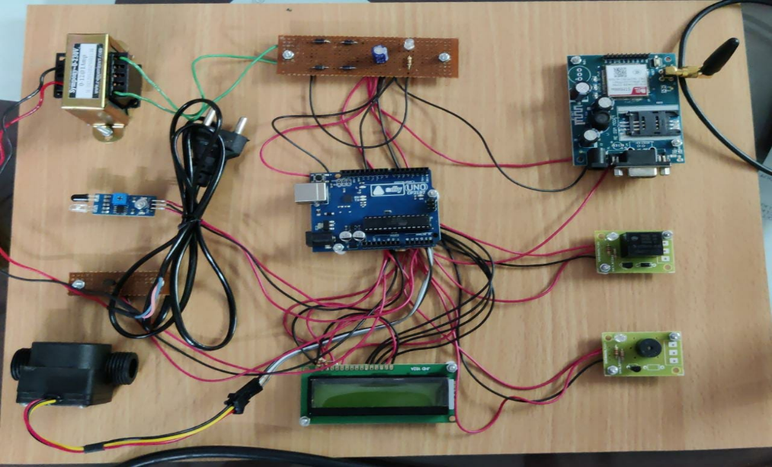

Fig: 6.1 Hardware Implementation

The above figure represents the overall hardware implementation of smart dialysis monitoring system. AC mains are described in order to fetch the power. Which is further step down transformer. Thus obtained AC signal is processed through bridge rectifier. Thus the obtained DC source is an unregulated and rippled DC power source, the capacitive filter and voltage regulator like 7805 are used to obtain regulated DC power source for the microcontroller operation. The LM35, I-R Sensor and flow sensor senses the parameters of the patient undergoing dialysis and the value fed to Arduino microcontroller unit. If the sensor values reaches the pre-determined value the dialysis procedure is cut-off and the alert alarm along with SMS notification is sent to the nurse station.

**6.2 Instrection and Data on LCD Display**

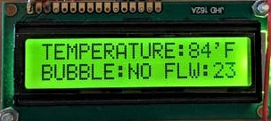

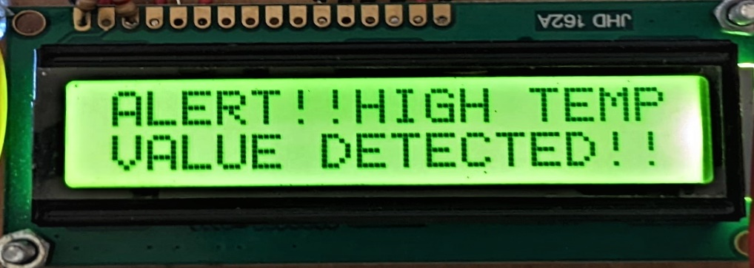

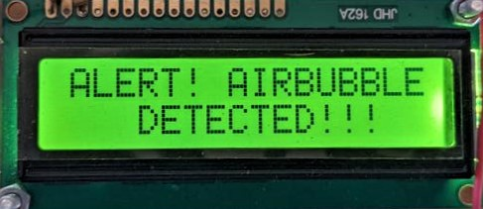

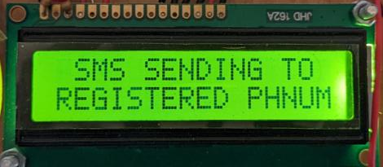

Fig: 6.2 Data logging in 16x2 LCD display

**6.3 SMS Notification Alert**

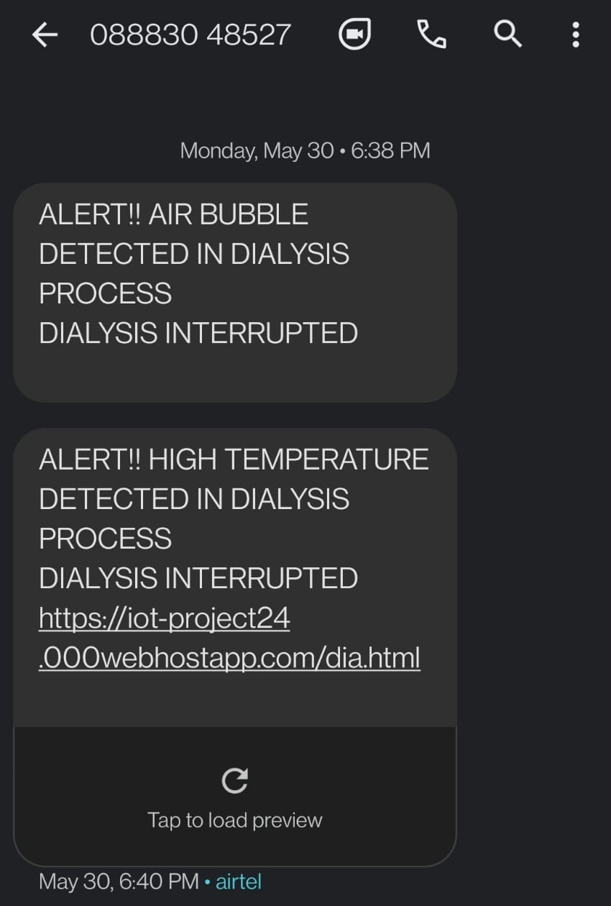

Fig: 6.3 SMS notification alert when problems detected

**6.4 Live Data Logging to Webpage**

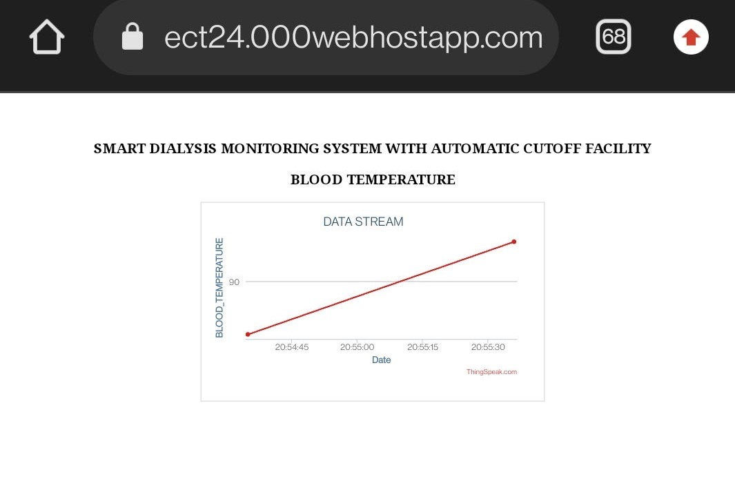

Fig: 6.4 Smart Dialysis Monitoring System data logging in webpage

**CHAPTER 7**

# CONCLUSION

By using this project we can monitor the patients dialysis parameters like temperature and blood flow continuously and it will be logged in to the cloud platform. Additionally when these parameters move beyond the pre-determined value, the alarm will be activated and SMS notification will be sent to the nurse station, it helps to activate the care taker immediately. Also when air bubbles are detected by the I-R the dialysis procedure is paused and SMS alert is sent to nurse station for immediate action to be taken.

The system which have been developed in this research can make development of dialysis procedure risk free. Also we can make the procedure contactless between patients and healthcare providers. The system is also capable of producing notification when abnormal condition is detected.

Overall, the application developed in Android device can functions properly in monitoring the whole dialysis procedure and received SMS notification when abnormality is detected.

# ANNEXURE

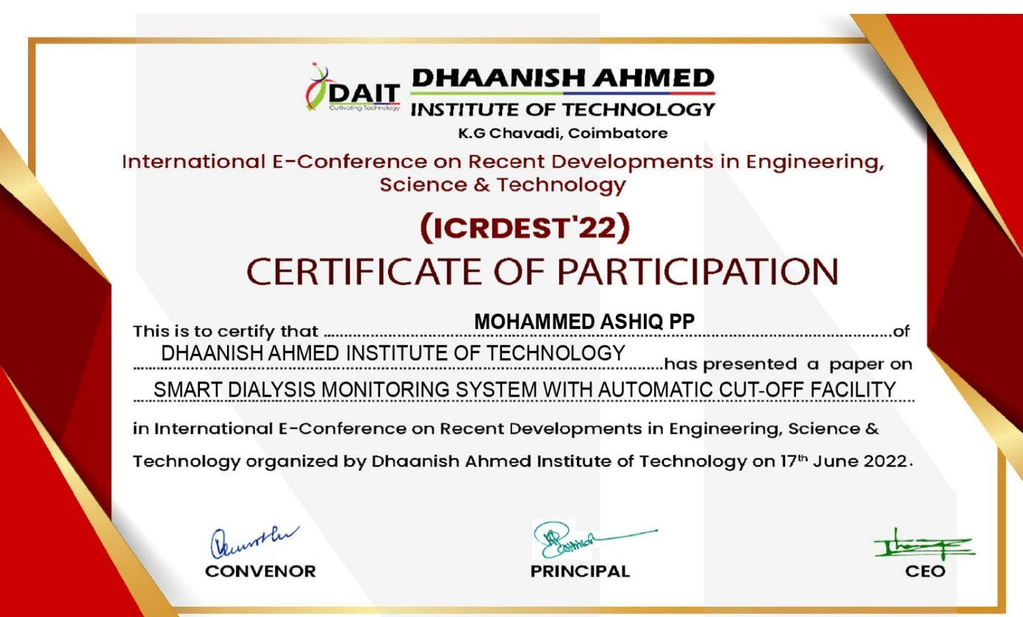

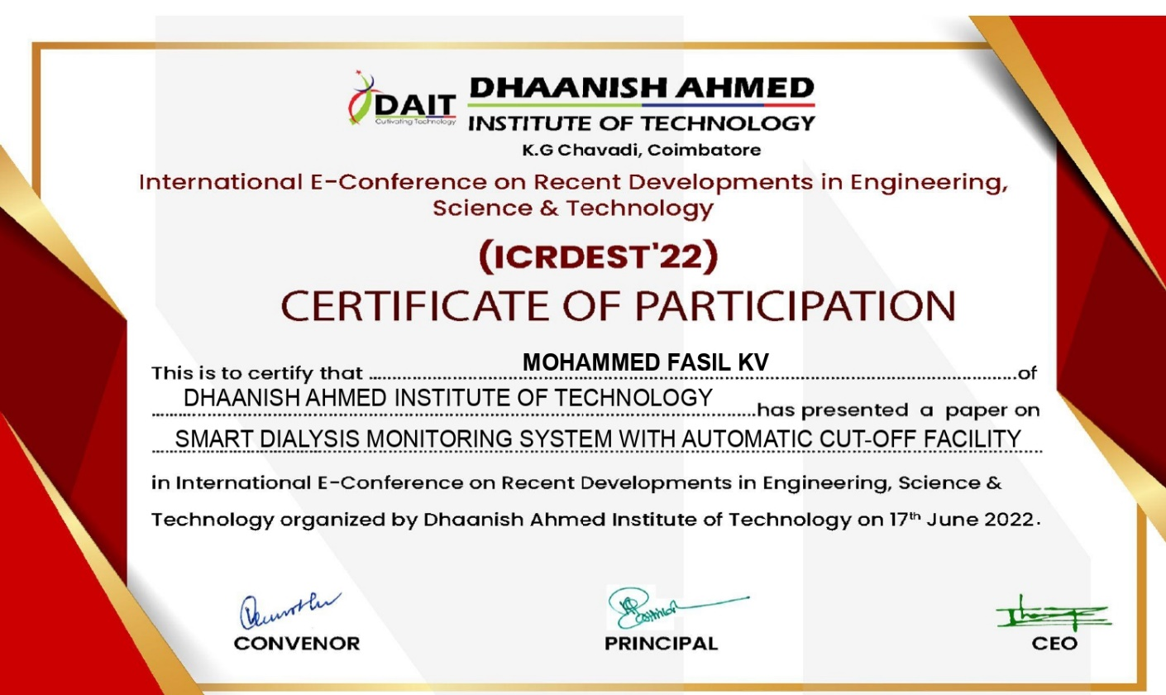

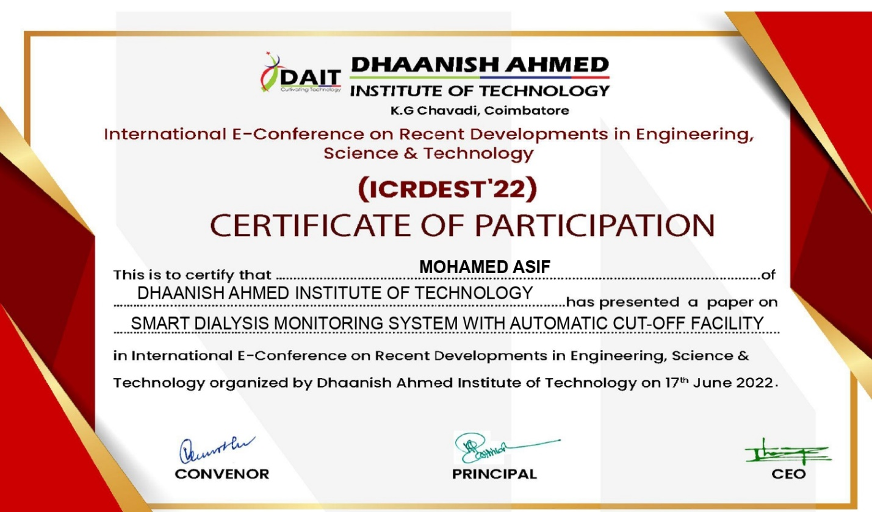

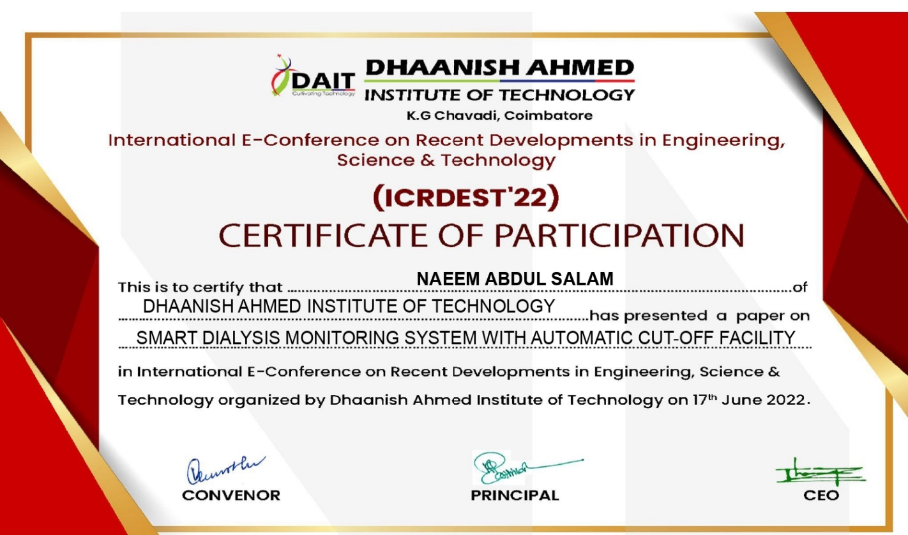

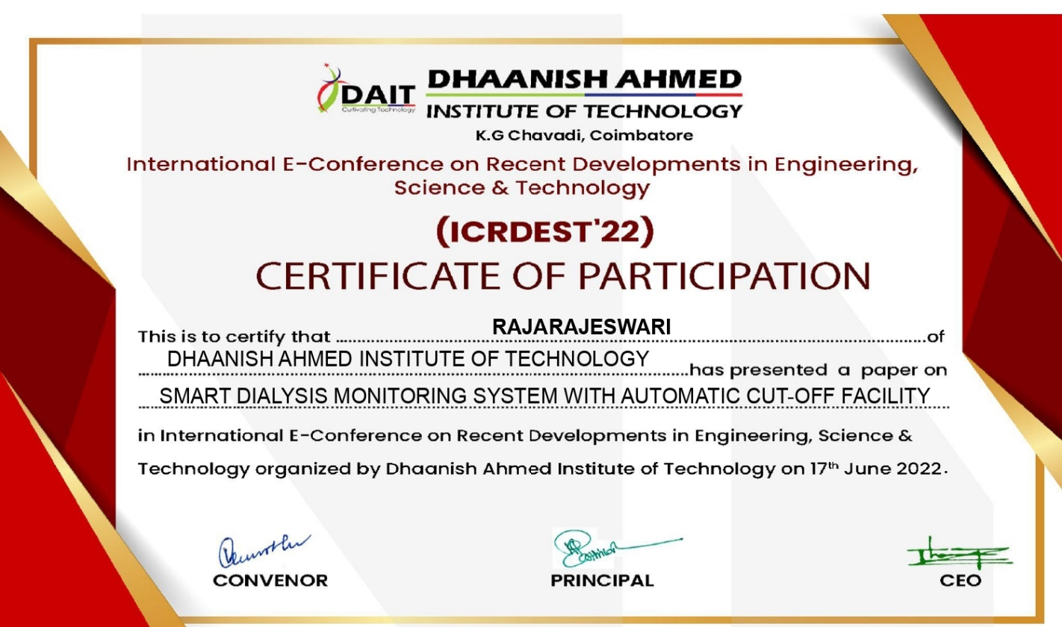

## REFERENCES

1. M. M. Ali, S. Haxha, M. M. Alam, C. Nwibor, and M. Sakel, “Design of Internet of Things (IoT) and Android Based Low Cost Health Monitoring Embedded System Wearable Sensor for Measuring SpO2, Heart Rate and Body Temperature Simultaneously,” Wirel. Pers. Commun., vol. 111, no. 4, pp. 2449–2463, doi: 10.1007/s11277- 019-06995-7, 2020.
2. OECD/WHO, Health at a Glance: Asia/Pacific, vol. 6011, no. 24312. 2020.
3. S. M. R. Islam, D. Kwak, M. H. Kabir, M. Hossain and K. Kwak, "TheInternet of Things for Health Care: A Comprehensive Survey," in IEEEAccess, vol. 3, pp. 678-708, 2015.
4. V. Pardeshi, S. Sagar, S. Murmurwar and P. Hage,"Health monitoring systems using loT and Raspberry Pi - A review," International Conference on Innovative Mechanisms for Industry Applications(ICIMIA) in Bangalore, pp. 134-137, 2017.
5. M. Ibharim, A. Albrni, F. Mohammad, N. Herencsar, J. Sampe, and S. H. Ali, “Novel Electronically Tunable Biquadratic Mixed- Mode Universal Filter Capable of Operating in MISO and SIMO Configurations,” J. Microelectron. Electron. Components Mater. vol. 50, no. 3, pp. 189–203, 2020.
6. Puthal, B.D, Malik, N., Mohanty, S.P., Kougianos, E. & Yang. C"The Block chain as a Decentralized Security Framework. S-11 2008.
7. Islam M. S., Islam M. T., Almutairi A. F., Beng G. K., Misran N., and Amin N., "Monitoring of the human body signal through the Internet of Things (loT) based LoRa wireless network system," Applied Sciences, vol. 9, no. 9, 2019.
8. Dauwed M. A., Yahaya J., Mansor Z., and Hamdan A. R."Determinants of internet of things services utilization in health information exchange," Journal of Engineering and Applied Sciences, vol. 13, no. 24, pp. 10490-10501, 2018.
9. Kohlová, M., Amorim, C.G., Araujo, A. “The biocompatibility and bioactivity of hemodialysis membranes: their impact in end- stage renal disease”. (2019).
10. K. Galatsis, W. Woldarsla, Y.X. Li and K. Kalantar-zadeh, “A Vehicle air quality monitor using gas sensors for
11. improved safety”, report in Recent Researches in Applications of Electrical and Computer Engineering
12. K. Galatsis, W. Woldarsla, Y.X. Li and K. Kalantar-zadeh, “A Vehicle air quality monitor using gas sensors for
13. improved safety”, report in Recent Researches in Applications of Electrical and Computer Engineering